|  |
| --- |
|  |
| PROJECT WRITEUP |
| AUTHOR: KAIRU JOSHUA WAMBUGU |
| REGISTRATION NUMBER: CS281-0720/2011 |
| DATE: Sunday, 27 September 2015 |

|  |
| --- |
|  |

# ACKNOWLEDGEMENTS

The following help has been received in the writing of this report:

* The Internet.
* The staff, Jomo Kenyatta University of Agriculture (JKUAT) ICT Centre of Excellence and Open Data (iCEOD).

# CONTENTS

ACKNOWLEDGEMENTS 2

CONTENTS 3

ABSTRACT 4

INTRODUCTION 5

METHODOLOGY 5

FINDINGS 5

DISCUSSION 5

1. The Web Service DontEat.At 6

2. The Web Site FixMyStreet.com 7

3. The National Pollutant Release Inventory(NPRI), Canada. 9

CONCLUSIONS 13

RECOMMENDATIONS 13

REFERENCES 14

# 

# LIST OF ILLUSTRATIONS

Figures 1 and 2 – DOHMH New York City Restaurant Inspection Results 6

Figure 3 - FixMyStreet.com Homepage……………………………………………………………………………………………. 8

Figure 4 - FixMyStreet.com Problem Report…………………………………………………………………………………….. 9

Figure 5a - Online NPRI data on Substances Released to the Air between 2009 and 2013……………... 10

Figure 5b - Online NPRI data on Substances Released to the Land between 2009 and 2013…………… 11

Figure 5c - Online NPRI data on Substances Released to Water Bodies between 2009 and 2013…... 12

Figure 6a - A NPRI Data Spreadsheet Showing Company Name, Facility Name, City, and Economic Region……………………………………………………………………………………………………………………………………………. 12

Figure 6b - A NPRI Data Spreadsheet Showing Information on Pollutant Substances Released to Air and Water………………………………………………………………………………………………………………………………………. 12

# ABSTRACT

This report contains three examples of open data applications. Information on the applications was found from desktop research online. The report comes to the conclusion that open data applications can really assist citizens increase the quality of their life. However, it is recommended that more open data sets be exposed since currently available sets do not cover many of the services ordinary citizens would want from open data.

# INTRODUCTION

This report aims to highlight some examples of the use of open data in economic development. Various implementations of open data have come up as individuals find ways to integrate data into their personal lives.

The report will showcase three such implementations of open data, giving background history, current use, and, where possible, a link to the implementation source code.

Information in this report was collected from desktop research on the Internet.

At the end of this report, a list of ways open data can be used locally will be presented.

# METHODOLOGY

In order to get this report compiled, it was decided that three examples of open data implementation would be needed. Searches for these examples were done online. Links to relevant pages were read, bookmarked, and will be referenced freely within this report.

To settle on which three examples to go for, issues such as relevance to the Kenyan setting, relevance to the environment, and success of implementation were checked. All three examples chosen have satisfied the report writer's desires as far as these issues are concerned.

# FINDINGS

The three examples of open data applications found are:

1. The web service DontEat.at.
2. The web site FixMyStreet.com.
3. The National Pollutant Release Inventory, Canada.

# DISCUSSION

We will consider each of the open data implementations mentioned above one at a time.

## The Web Service DontEat.At

This web service is made by a resident of New York City named Mark Stoller. It is based on the idea that everyone at one time or another has had a bad day because of eating unhygienic food at supposedly licensed food vendors.

New York City’s Department of Health and Mental Hygiene (DOHMH) checks eating establishments for consistency with hygiene standards and keeps the results of these checks in an open data set that is updated weekly. Below are two pictures that show how a section of this data set looks like.

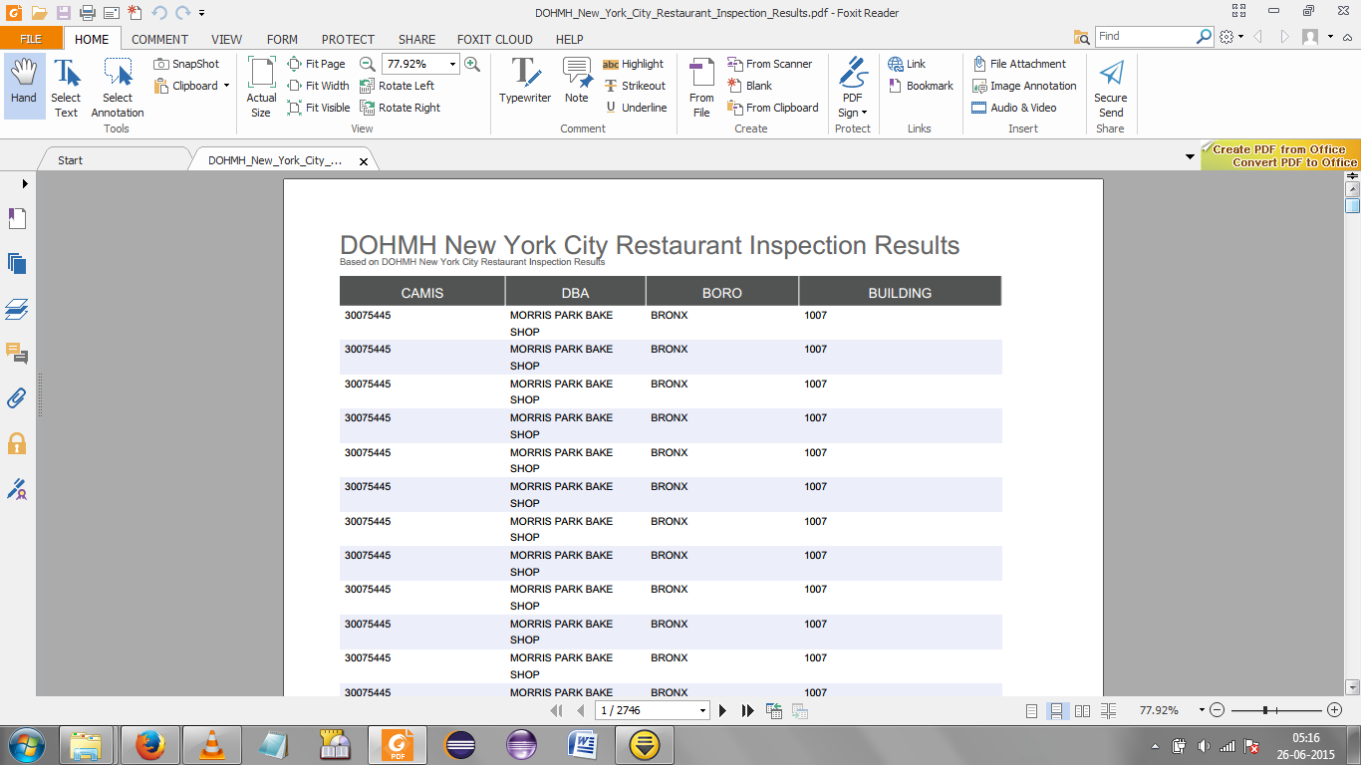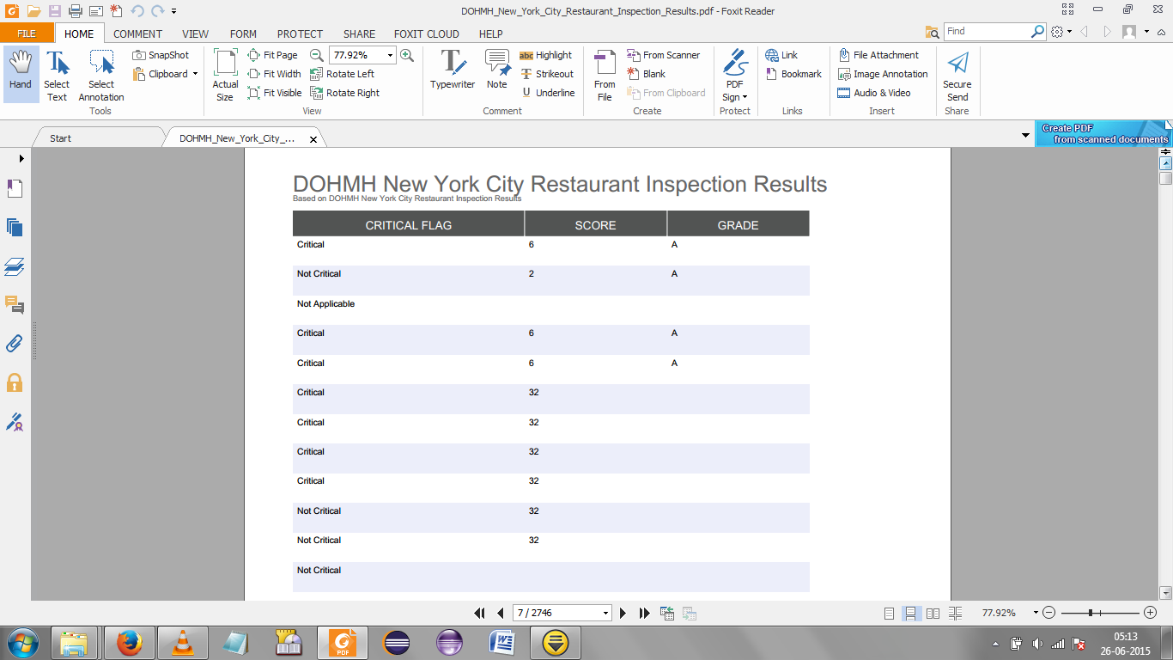

Figures and 2 – DOHMH New York City Restaurant Inspection Results

Below is an explanation of the columns in the above data set.

* The CAMIS stands for the City-wide Agency Management Information System, a system responsible for managing city agencies within New York. (DiNapoli 2007)
* The DBA stands for Doing-Business-As, which is a legal term in the United States used to mean that the trade name under which a particular business is registered is not the legal name of the person(s) owning the business.(Doing business as - Wikipedia, the free encyclopedia 2015)
* BORO stands for the Borough within which the business is located.
* BUILDING represents the building number where the business is located.
* CRITICAL FLAG shows the severity of health code violations in a certain eating outlet.
* SCORE shows the score the health inspector gave the eatery the last time inspection was done. The higher the score the more unhygienic the restaurant. A score of 28 or more lands a restaurant on a flagged list that triggers repeated inspections or even a shut-down if scores do not reduce. (Drake Martinet, Associate Editor, All Things Digital, 2011, “Early Adopter: Think That Restaurant Looks Shady? DontEat.At Lets You Know for Sure”, para. 7)
* GRADE shows the final grade the health inspector awarded the restaurant during the latest inspection. This could be left pending if an initial inspection ended up in a closure.

As mentioned, restaurants with high scores are kept in a flagged list. DontEat.At looks at this list to help its users know which food joints to avoid. A user simply registers their FourSquare app with DontEat.At then he/she will get a notification every time they visit an eatery on the flagged list warning them of the circumstances they might end up getting themselves in.

This service is currently available only in New York City but plans are being thought up to implement it in other cities such as San Francisco.

Source code for this service can be found at Max Stoller’s GitHub page <https://github.com/maxstoller/donteatat>.

## The Web Site FixMyStreet.com

FixMyStreet.com is a websitre for reporting problems on local street level. The software used to make the website is free and open source. FixMyStreet.com is based in the United Kingdom and started in 2007. Problems that can be reported on this site include graffiti, overgrown hedges, upturned signposts, and chipped curb stones.

Users of the site identify the location of the problem using a map available on the site itself. Users also give details about the anomaly such as a photo and a description. The website collects this information into a complaint and sends it to relevant authorities.

Relevant authorities have an opportunity to subscribe to the site via RSS Feed or email so that they can get updated on any problems within their localities.

FixMyStreet.com has been implemented in various United Kingdom councils such as Bromley, Warwickshire, Stevenage Borough, Oxfordshire, and Barnet. (FixMyStreet for Councils :: FixMyStreet 2015) It has also been used outside the UK, in Zürich – under the name Züri wie neu, which translated as ‘Zürich: Good As New’(FixMyZurich, 2013); and in Norway – under the web site <http://www.fiksgatami.no/>.

Below is a screenshot of the homepage of the English version of FixMyStreet.com.

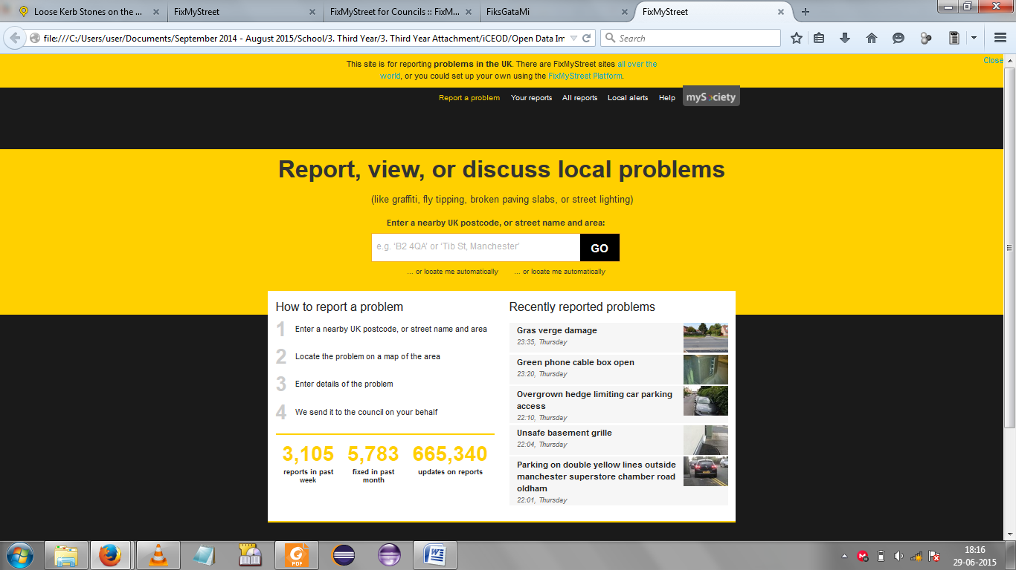

Figure 3 - FixMyStreet.com Homepage

The screenshot below shows a recently reported problem on FixMyStreet.com.

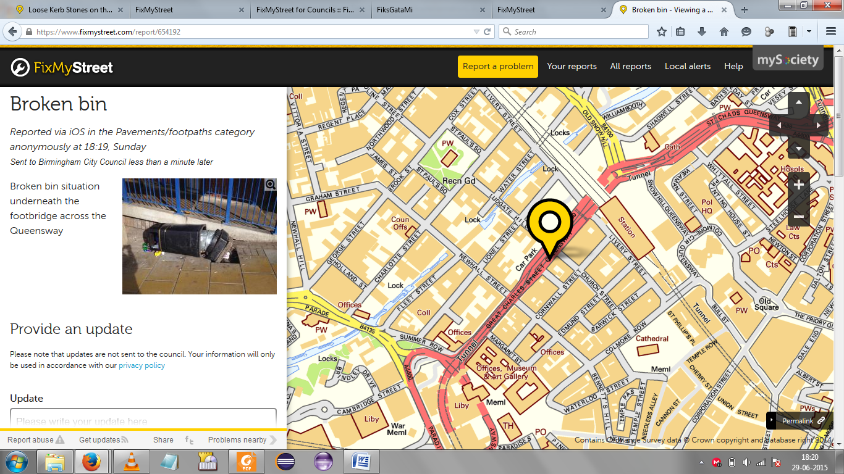

Figure 4 - FixMyStreet.com Problem Report

Developers of FixMyStreet have made a platform – the FixMyStreet Platform – which is easily adaptable into several use cases. For example, the FixMyStreet Platform is being used in the Philippines as a text message service. (The FixMyStreet Platform DIY Guide version 1.1, 2015)

Source code for the FixMyStreet Platform can be found in their GitHub page <https://github.com/mysociety/fixmystreet>.

## The National Pollutant Release Inventory(NPRI), Canada.

This is a collection of open data about various forms of pollutants present in the nation of Canada.

According to its website <http://open.canada.ca/en/apps/national-pollutant-release-inventory>, NPRI is Canada’s legislated, publicly accessible inventory of pollutant releases, disposals, and transfers for recycling. It is useful in identifying pollution prevention priorities, supporting air quality management, and improving public knowledge about the spread of pollutants within the nation.

NPRI monitors pollution releases for institutions such as industries and commercial enterprises based on specific standards. It puts this data in a format that can either be viewed online or downloaded.

Below are a few screenshots showcasing NPRI data both on the Internet and in downloaded form. Figures 5a, 5b, and 5c show online NPRI data while Figures 6a and 6b are from a single NPRI spreadsheet file updated September 16, 2014.

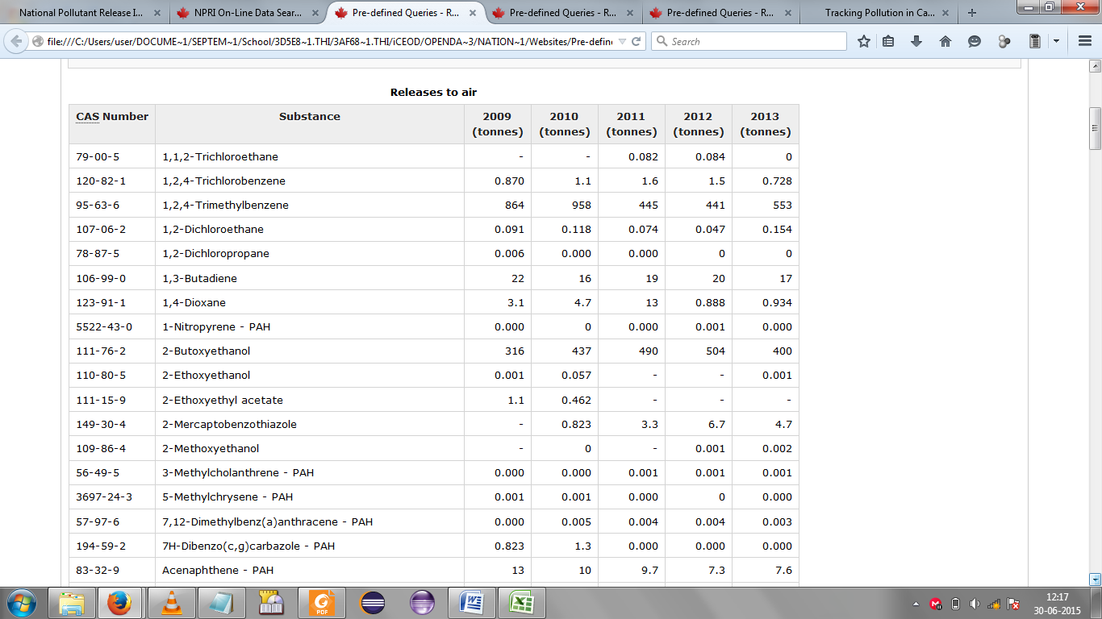

Figure 5a - Online NPRI data on Substances Released to the Air between 2009 and 2013

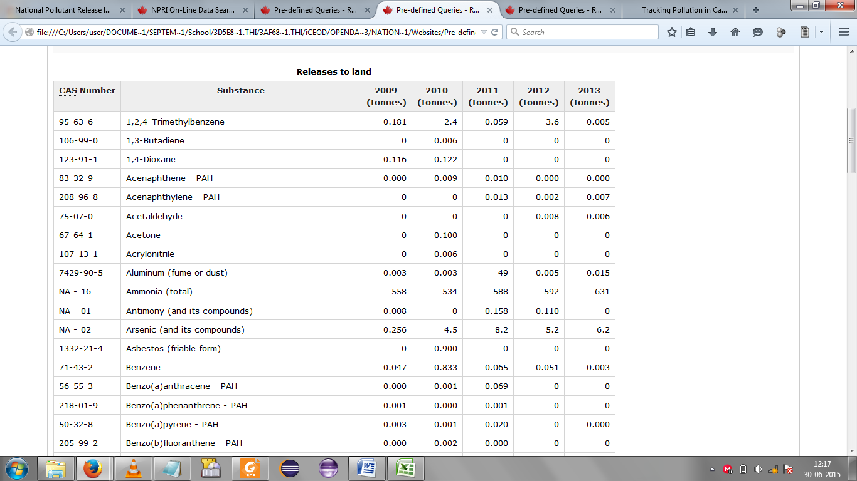

Figure 5b - Online NPRI data on Substances Released to the Land between 2009 and 2013

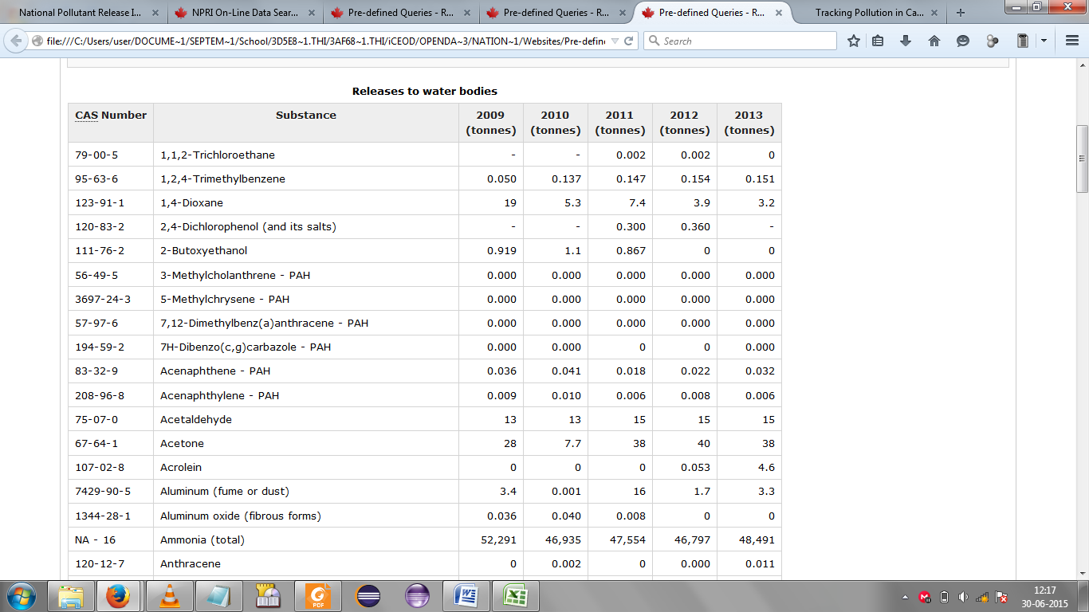

Figure 5c - Online NPRI data on Substances Released to Water Bodies between 2009 and 2013

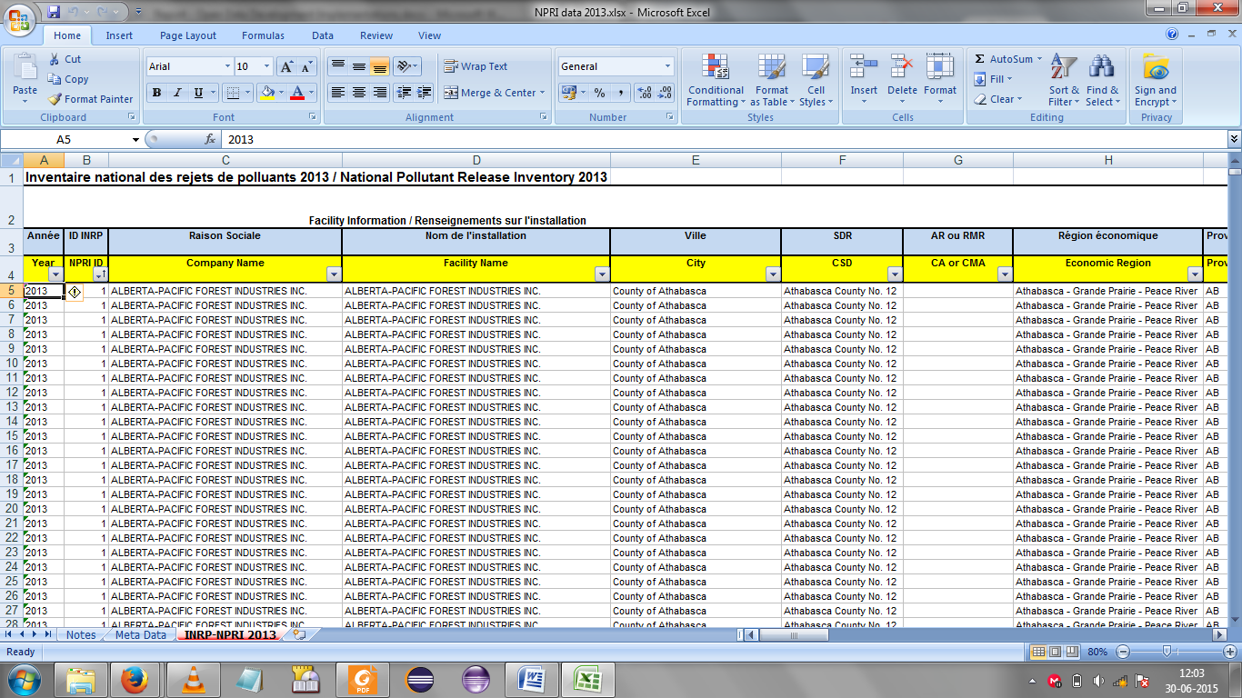

Figure 6a - A NPRI Data Spreadsheet Showing Company Name, Facility Name, City, and Economic Region

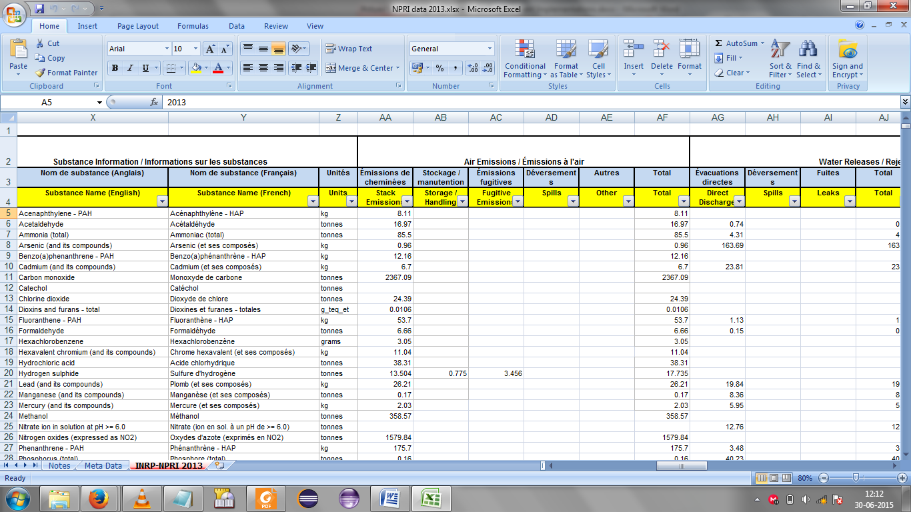

Figure 6b - A NPRI Data Spreadsheet Showing Information on Pollutant Substances Released to Air and Water

From the three examples above it is clear that open data can be used as a force for good in whichever community it is exposed to. Could open data be used to improve our local lives within the country of Kenya? Below is a list of Kenyan Government institutions and the services developers might provide to citizens if those institutions expose some of their data in open form. The list is by no means exhaustive since open data has a very wide range of applications.

1. Kenya Power.

* They could expose open data sets that would allow Kenyans to know the time, place, and duration of a power outage.

1. The Kenya Revenue Authority.(KRA)

* They could expose data sets that would help citizens know the closest offices to pay their annual tax returns, the average times of service in those offices, the average length of queues in those offices, and the time left before tax returns deadlines.

1. The National Hospital Insurance Fund. (NHIF)

* They could provide data sets that will inform people concerning hospitals associated with specific NHIF offices, maximum allowable rates for individuals in various job groups, as well average queue lengths and times of service in NHIF offices.

1. The Energy Regulatory Commission. (ERC)

* The ERC could team up with individual petrol stations to provide data sets on current fuel prices in those petrol stations. Such data sets would then be used to help commuters determine where to find the cheapest fuel within, say, a five kilometre radius.

# CONCLUSIONS

Open data has a very important niche in the fast-paced information world we live in. It is being used in so many ways to provide services to any and all. The cooperation between open data owners such as governments and open data users such as developers is something very encouraging. Open data is helping citizens to be more aware of their environment, their leaders, their problems, their legislation, and their safety, just to mention a few. It is giving the person on the street more control over their life. This is very important if an assertive, motivated society is to be built and maintained. Open data also allows developers to use their skills and creativity to solve problems for others. It is a documented fact that assisting others is good for one’s wellbeing. Thus there are enough reasons for mutual understanding and cooperation between open data owners and users to be carefully nurtured and grown.

# RECOMMENDATIONS

Some recommendations that come to mind after the compilation of this report are:

1. The Kenyan open data repository needs more data and Application Program Interfaces(APIs) if it will be of benefit to local citizens.
2. The Kenyan open data sets need more updates so that users will be assured that they are using the latest, most relevant data in any open data applications of their choice.

# REFERENCES

* Becky Hogge 2012, *Can we fix it*, viewed 26 June 2015, <http://fixmystreet.org/The-FixMyStreet-Platform-DIY-Guide-v1.1.pdf>.
* Broken bin - Viewing a problem :: FixMyStreet 2015, viewed 26 June 2015, <https://www.fixmystreet.com/report/654192>.
* DiNapoli, T. P., 2007, *NEW YORK CITY DEPARTMENT OF CONSUMER AFFAIRS CONTROLS OVER RESTAURANT AND FOOD VENDOR LICENSES AND PERMITS Report 2007-N-15*, New York City, NY, viewed 26 June 2015, <http://osc.state.ny.us/audits/allaudits/093008/07n15.pdf>.
* Doing business as - Wikipedia, the free encyclopedia, 2015, Wikipedia, viewed 29 June 2015, <https://en.wikipedia.org/wiki/Doing_business_as>.
* Drake Martinet 2011, *Early Adopter: Think That Restaurant Looks Shady? Donteat.at Lets You Know for Sure*, Drake Martinet, viewed 26 June 2015, <http://allthingsd.com/20110225/early-adopter-think-that-restaurant-looks-shady-donteat-at-lets-you-know-for-sure/>.
* FixMyStreet 2015, *FixMyStreet for Councils :: FixMyStreet*, FixMyStreet, viewed 26 June 2015, <https://www.fixmystreet.com/council>.
* FixMyStreet 2015, viewed 26 June 2015, <https://www.fixmystreet.com/>.
* Government of Canada 2013, *National Pollutant Release Inventory 2013*, viewed 26 June 2015, <http://ec.gc.ca/inrp-npri/donnees-data/files/2013_INRP-NPRI_2014-09-16.xlsx>.
* Myf 2014, *FixMyZurich*, viewed 26 June 2015, <https://www.mysociety.org/files/2014/03/FixMyStreet-for-Councils-Zurich-case-study.pdf>.
* National Pollutant Release Inventory | Open Government 2015, NPRI, Canada, viewed 26 June 2015, <http://open.canada.ca/en/apps/national-pollutant-release-inventory>.
* NYC OpenData, 2015, *DOHMH New York City Restaurant Inspection Results*, New York City, NY, viewed 26 June 2015, <https://data.cityofnewyork.us/Health/DOHMH-New-York-City-Restaurant-Inspection-Results/xx67-kt59>.
* Pre-defined Queries - Reported Pollution Data Search - Environment Canada 2014, NPRI, Canada, viewed 26 June 2015, <http://www.ec.gc.ca/inrp-npri/donnees-data/index.cfm?do=common&lang=en&common_query=3&query_type=1>.
* Pre-defined Queries - Reported Pollution Data Search - Environment Canada 2014, NPRI, Canada, viewed 26 June 2015, <http://www.ec.gc.ca/inrp-npri/donnees-data/index.cfm?do=common&lang=en&common_query=3&query_type=2>.
* Pre-defined Queries - Reported Pollution Data Search - Environment Canada 2014, NPRI, Canada, viewed 26 June 2015, <http://www.ec.gc.ca/inrp-npri/donnees-data/index.cfm?do=common&lang=en&common_query=3&query_type=3>.